**Appendix Table 1.1.** List of models for the **24-H Period** where delta (Δ) < 2.

|  |  |  |  |  |  |  |
| --- | --- | --- | --- | --- | --- | --- |
| 1= Maximum Temperature (T) | | 2= Rainfall (R) | | 3=Moonlight (M) | | |
| 4= Day Length (DL) | | 5= Denning (D) (Yes) | | 6= Pup Age (PA) | | |
| 7= Litter Size (LS) | | 8= Pack Size (PS) | | 9= Days at Den (DaD) | | |
| 10= Maximum Temperature*Rainfall | | 11=Days at Den*Maximum Temperature | | 12 = Maximum Temperature*Denning (Yes) | | |
| 13= Age of pups*Litter Size | | 14= Pup Age*Pack Size | |  | | |
|  | |  | |  | | |
| **Dependent variable** | **Period** | | **Independent variables** | | ***AICc*** | ***Delta*** |
| ***Distance travelled*** | All | | 1 8 | | 8643.4 | 0 |
| 1 2 3 4 5 8 | | 8643.97 | 0.58 |
| 1 2 3 4 8 | | 8644.29 | 0.89 |
| 1 4 | | 8645.12 | 1.72 |
| 1 2 8 | | 8645.27 | 1.88 |
| 1 2 3 4 5 8 12 | | 8645.33 | 1.93 |
| Denning | | 4 | | 1858.8 | 0 |
| 1 2 3 4 6 | | 1859.42 | 0.62 |
| 6 | | 1859.46 | 0.66 |
| 1 6 | | 1859.97 | 1.17 |
| 1 | | 1860.01 | 1.21 |
| 3 | | 1860.15 | 1.35 |
| 8 | | 1860.2 | 1.4 |
| 7 | | 1860.43 | 1.63 |
| 1 2 3 4 6 7 | | 1860.69 | 1.89 |
| 1 4 | | 1860.71 | 1.91 |

**Appendix Table 1.2.** List of models for the **Morning Period** where delta (Δ) < 2.

|  |  |  |  |  |  |  |  |
| --- | --- | --- | --- | --- | --- | --- | --- |
| 1= Maximum Temperature (T) | | | 2= Rainfall (R) | | 3=Moonlight (M) | | |
| 4= Day Length (DL) | | | 5= Denning (D) (Yes) | | 6= Pup Age (PA) | | |
| 7= Litter Size (LS) | | | 8= Pack Size (PS) | | 9= Days at Den (DaD) | | |
| 10= Maximum Temperature*Rainfall | | | 11=Days at Den*Maximum Temperature | | 12 = Maximum Temperature*Denning (Yes) | | |
| 13= Age of pups*Litter Size | | | 14= Pup Age*Pack Size | |  | | |
|  | |  | | |  | | |
| **Dependent variable** | **Period** | | | **Independent variables** | | ***AICc*** | ***Delta*** |
| ***Distance travelled*** | All | | | 1 2 3 4 | | 9888.51 | 0 |
| 1 2 3 4 5 | | 9889.71 | 1.21 |
| 1 2 3 4 5 10 | | 9890.32 | 1.81 |
| Denning | | | 1 2 3 4 | | 1689.93 | 0 |
| 1 2 3 4 6 10 | | 1690.38 | 0.45 |
| 1 2 3 4 10 | | 1691.04 | 1.1 |

**Appendix Table 1.3.** List of models for the **Evening Period** where delta (Δ) < 2.

|  |  |  |  |  |  |  |  |
| --- | --- | --- | --- | --- | --- | --- | --- |
| 1= Maximum Temperature (T) | | | 2= Rainfall (R) | | 3=Moonlight (M) | | |
| 4= Day Length (DL) | | | 5= Denning (D) (Yes) | | 6= Pup Age (PA) | | |
| 7= Litter Size (LS) | | | 8= Pack Size (PS) | | 9= Days at Den (DaD) | | |
| 10= Maximum Temperature*Rainfall | | | 11=Days at Den*Maximum Temperature | | 12 = Maximum Temperature*Denning (Yes) | | |
| 13= Age of pups*Litter Size | | | 14= Pup Age*Pack Size | |  | | |
|  | |  | | |  | | |
| **Dependent variable** | **Period** | | | **Independent variables** | | ***AICc*** | ***Delta*** |
| ***Distance travelled*** | All | | | 1 2 3 4 5 8 | | 7189.68 | 0 |
| 1 2 3 4 5 8 10 | | 7190.28 | 0.61 |
| 1 2 3 4 5 8 12 | | 7190.73 | 1.05 |
| 1 2 3 4 5 8 10 12 | | 7191.43 | 1.75 |
| Denning | | | 1 4 | | 1331.77 | 0 |
| 1 | | 1332.13 | 0.36 |
| 1 8 | | 1333.52 | 1.75 |
| 1 2 4 | | 1333.68 | 1.91 |

**Appendix Table 1.4.** List of models for the **Night Period** where delta (Δ) < 2.

|  |  |  |  |  |  |  |  |
| --- | --- | --- | --- | --- | --- | --- | --- |
| 1= Maximum Temperature (T) | | | 2= Rainfall (R) | | 3=Moonlight (M) | | |
| 4= Day Length (DL) | | | 5= Denning (D) (Yes) | | 6= Pup Age (PA) | | |
| 7= Litter Size (LS) | | | 8= Pack Size (PS) | | 9= Days at Den (DaD) | | |
| 10= Maximum Temperature*Rainfall | | | 11=Days at Den*Maximum Temperature | | 12 = Maximum Temperature*Denning (Yes) | | |
| 13= Age of pups*Litter Size | | | 14= Pup Age*Pack Size | |  | | |
|  | |  | | |  | | |
| **Dependent variable** | **Period** | | | **Independent variables** | | ***AICc*** | ***Delta*** |
| ***Distance travelled*** | All | | | 1 2 3 5 | | 7063.79 | 0 |
| 1 2 3 5 12 | | 7064.63 | 0.84 |
| 1 2 3 4 5 10 | | 7065.49 | 1.7 |
| 1 2 3 4 5 | | 7065.66 | 1.87 |
| Denning | | | 1 2 3 4 6 7 8 9 11 | | 1088.64 | 0 |
| 1 2 3 4 9 11 | | 1089.36 | 0.72 |
| 1 2 3 4 6 9 11 | | 1089.7 | 1.07 |

|  |  |  |  |  |
| --- | --- | --- | --- | --- |
| **Appendix Table 2.1.** Variables associated with wild dog distance travelled across the **24-H Period (05:00 – 05:00).** Variable estimates were generated using generalized linear mixed effects models. The residuals of the models were gamma distributed and therefore the exponent of the values should be taken to obtain true estimates. All outputs are from averaged Δ<2 models. Relative importance of each parameter is shown along with the number of models in the Δ < 2 and Δ < 5 model sets that contain each variable (n, n). Variables with an importance of 0 were not in models with Δ < 2. * denotes an interaction between two variables. Individual identity (ID) was included as a random effect. | | | | |
| Period | Variable | Distance travelled | | |
| Estimate | 95% Confidence interval | Importance (Δ <2, Δ <5) |
| ALL | Intercept | 2.33 | 2.2 to 2.5 |  |
|  | Maximum Temperature (C) | -0.011 | -0.02 to -0.004 | 1.00 (6,12) |
|  | Daily Rainfall (mm) | 0.000017 | -0.004 to 0.004 | 0.6 (4, 7) |
|  | Moonlight | 0.0010 | -0.004 to 0.009 | 0.49 (3, 6) |
|  | Day Length (H) | -0.47 | -1.9 to 0.3 | 0.61 (4, 8) |
|  | Denning (Yes) | 0.026 | -0.02 to 0.2 | 0.32 (2, 5) |
|  | Pack Size | -0.0078 | -0.02 to -0.001 | 0.88 (5, 8) |
|  | *Temperature*Rainfall* | *Not in Δ < 2* | *Not in Δ < 2* | *0 (0, 1)* |
|  | Temperature*Denning (Yes) | 0.00074 | -0.01 to 0.02 | 0.11 (1, 2) |
| DENNING | Intercept | 2.09 | 1.5 to 2.6 |  |
|  | Maximum Temperature (C) | -0.0032 | -0.03 to 0.01 | 0.45 (5, 28) |
|  | Daily Rainfall (mm) | 0.00065 | -0.02 to 0.02 | 0.19 (2, 20) |
|  | Moonlight | -0.0023 | -0.02 to 0.008 | 0.28 (3, 16) |
|  | Day Length (H) | -2.84 | -15.1 to 2.0 | 0.43 (4, 15) |
|  | Pup Age (Days) | 0.0014 | -0.001 to 0.008 | 0.42 (4, 18) |
|  | Litter Size | 0.00027 | -0.04 to 0.05 | 0.14 (2, 10) |
|  | Pack Size | -0.00060 | -0.02 to 0.01 | 0.09 (1, 7) |
|  | *Days at Den* | *Not in Δ < 2* | *Not in Δ < 2* | *0.00 (0, 6)* |
|  | *Maximum Temperature*Daily Rainfall* | *Not in Δ < 2* | *Not in Δ < 2* | *0.00 (0, 2)* |
|  | *Maximum Temperature*Days at Den* | *Not in Δ < 2* | *Not in Δ < 2* | *0.00 (2, 2)* |
|  | *Pup Age*Litter Size* | *Not in Δ < 2* | *Not in Δ < 2* | *0.00 (0, 3)* |
|  | *Pup Age*Pack Size* | *Not in Δ < 2* | *Not in Δ < 2* | *0.00 (0, 2)* |

|  |  |  |  |  |
| --- | --- | --- | --- | --- |
| **Appendix Table 2.2.** Variables associated with wild dog distance travelled across the **Morning Period (05:00 – 12:00) .** Variable estimates were generated using generalized linear mixed effects models. The residuals of the models were gamma distributed and therefore the exponent of the values should be taken to obtain true estimates. All outputs are from averaged delta (Δ)<2 models. Relative importance of each parameter is shown along with the number of models in the Δ < 2 and Δ < 5 model sets that contain each variable (n, n). Variables with an importance of 0 were not in models with Δ < 2. * denotes an interaction between two variables. Variables where no estimate is shown (*Days at Den*, *Maximum Temperature*Days at Den, Age of pups*Litter size, Age of pups*Pack Size*) were not in the Δ<2 or Δ<5 model sets. Individual identity (ID) was included as a random variable. | | | | |
| Period | Variable | Distance travelled | | |
| Estimate | 95% Confidence interval | Importance (Δ <2, Δ <5) |
| ALL | Intercept | 1.61 | 1.5 to 1.7 |  |
|  | Maximum Temperature (C) | -0.000016 | -0.009 to 0.009 | 1.00 (3, 9) |
|  | Daily Rainfall (mm) | -0.000027 | -0.005 to 0.005 | 1.00 (3, 9) |
|  | Moonlight | -0.017 | -0.02 to -0.007 | 1.00 (3, 9) |
|  | Day Length (H) | -2.60 | -4.0 to -1.2 | 1.00 (3, 9) |
|  | Denning (Yes) | 0.015 | -0.06 to 0.2 | 0.28 (1, 6) |
|  | *Pack Size* | *Not in Δ < 2* | *Not in Δ < 2* | *0.00 (0, 4)* |
|  | *Temperature*Rainfall* | 0.00004 | -0.0007 to 0.001 | 0.21 (1, 3) |
|  | *Temperature*Denning (Yes)* | *Not in Δ < 2* | *Not in Δ < 2* | *0.00 (0, 2)* |
| DENNING | Intercept | 1.22 | 0.27 to 2.2 |  |
| Maximum Temperature (C) | -0.014 | -0.04 to 0.01 | 1.00 (3, 5) |
| Daily Rainfall (mm) | -0.038 | -0.1 to 0.04 | 1.00 (3, 5) |
| Moonlight | -0.050 | -0.07 to -0.03 | 1.00 (3, 5) |
| Day Length (H) | -3.51 | -14.9 to 2.9 | 0.58 (2, 4) |
| Pup Age (Days) | 0.0012 | -0.0006 to 0.008 | 0.34 (1, 3) |
| Litter Size | *Not in Δ < 2* | *Not in Δ < 2* | *0.00 (0, 2)* |
| Pack Size | *Not in Δ < 2* | *Not in Δ < 2* | *0.00 (0, 1)* |
| *Maximum Temperature*Daily Rainfall* | -0.021 | -0.03 to -0.01 | 1.00 (3, 5) |

|  |  |  |  |  |
| --- | --- | --- | --- | --- |
| **Appendix Table 2.3.** Variables associated with wild dog distance travelled across the **Evening Period (12:00 – 19:00).** Variable estimates were generated using generalized linear mixed effects models. The residuals of the models were gamma distributed and therefore the exponent of the values should be taken to obtain true estimates. All outputs are from averaged Δ<2 models. Relative importance of each parameter is shown along with the number of models in the Δ < 2 and Δ < 5 model sets that contain each variable (n, n). Variables with an importance of 0 were not in models with Δ < 2. * denotes an interaction between two variables. Variables where no estimate is shown (*Litter Size*, *Age of Pups*Litter Size*)were not in the Δ<2 or Δ<5 model sets. Individual identity (ID) was included as a random variable. | | | | |
| Period | Variable | Distance travelled | | |
| Estimate | 95% Confidence interval | Importance (Δ <2, Δ <5) |
| ALL | Intercept | 1.18 | 1.0 to 1.4 |  |
| Maximum Temperature (C) | -0.043 | -0.05 to -0.03 | 1.00 (4, 4) |
| Daily Rainfall (mm) | 0.0089 | 0.002 to 0.02 | 1.00 (4, 4) |
| Moonlight | -0.026 | -0.04 to -0.01 | 1.00 (4, 4) |
| Day Length (H) | 2.99 | 1.6 to 4.4 | 1.00 (4, 4) |
| Denning (Yes) | 0.64 | 0.5 to 0.8 | 1.00 (4, 4) |
| Pack Size | -0.019 | -0.03 to -0.008 | 1.00 (4, 4) |
| Temperature*Rainfall | 0.00028 | -0.0004 to 0.002 | 0.42 (2, 2) |
| Temperature*Denning (Yes) | -0.0050 | -0.04 to 0.01 | 0.37 (2, 2) |
| DENNING | Intercept | 1.12 | 0.7 to 1.5 |  |
| Maximum Temperature (C) | -0.045 | -0.07 to -0.02 | 1.00 (4, 16) |
| Daily Rainfall (mm) | 0.00095 | -0.03 to 0.04 | 0.15 (1, 8) |
| Moonlight | *Not in Δ < 2* | *Not in Δ < 2* | *0.00 (0, 3)* |
| Day Length (H) | -2.95 | -12.6 to 1.3 | 0.52 (2, 3) |
| Pup Age (Days) | *Not in Δ < 2* | *Not in Δ < 2* | *0.00 (0, 3)* |
| Pack Size | -0.0015 | -0.03 to 0.01 | 0.16 (1, 3) |
| *Days at Den* | *Not in Δ < 2* | *Not in Δ < 2* | *0.00 (0, 3)* |
| *Maximum Temperature*Daily Rainfall* | *Not in Δ < 2* | *Not in Δ < 2* | *0.00 (0, 1)* |
| *Maximum Temperature*Days at Den* | *Not in Δ < 2* | *Not in Δ < 2* | *0.00 (0, 1)* |
| *Pup Age*Pack Size* | *Not in Δ < 2* | *Not in Δ < 2* | *0.00 (0, 1)* |

|  |  |  |  |  |
| --- | --- | --- | --- | --- |
| **Appendix Table 2.4.** Variables associated with wild dog distance travelled across the **Night Period (19:00 – 05:00).** Variable estimates were generated using generalized linear mixed effects models. The residuals of the models were gamma distributed and therefore the exponent of the values should be taken to obtain true estimates. All outputs are from averaged Δ<2 models. Relative importance of each parameter is shown along with the number of models in the Δ < 2 and Δ < 5 model sets that contain each variable (n, n). Variables with an Importance of 0 were not in models with Δ < 2. * denotes an interaction between two variables. Individual identity (ID) was included as a random variable. | | | | |
| Period | Variable | Distance travelled | | |
| Estimate | 95% Confidence interval | Importance (Δ <2, Δ <5) |
| ALL | Intercept | 0.37 | 0.3 to 0.5 |  |
|  | Maximum Temperature (C) | 0.00093 | -0.01 to 0.01 | 1.00 (4, 9) |
|  | Daily Rainfall (mm) | -0.0079 | -0.02 to -0.0004 | 1.00 (4, 9) |
|  | Moonlight | 0.079 | 0.07 to 0.09 | 1.00 (4, 9) |
|  | Day Length (H) | -0.11 | -2.4 to 1.7 | 0.33 (2, 6) |
|  | Denning (Yes) | 0.48 | 0.3 to 0.7 | 1.00 (4, 8) |
|  | Pack Size | *Not in Δ < 2* | *Not in Δ < 2* | *0.00 (0, 3)* |
|  | Temperature*Rainfall | 0.00014 | -0.0002 to 0.002 | 0.17 (1, 3) |
|  | Temperature*Denning (Yes) | -0.0070 | -0.07 to 0.02 | 0.27 (1, 4) |
| DENNING | Intercept | 0.27 | -0.2 to 0.7 |  |
|  | Maximum Temperature (C) | 0.069 | 0.02 to 0.1 | 1.00 (3, 16) |
|  | Daily Rainfall (mm) | -0.037 | -0.07 to -0.008 | 1.00 (3, 16) |
|  | Moonlight | 0.079 | 0.05 to 0.1 | 1.00 (3, 16) |
|  | Day Length (H) | -18.81 | -28.8 to -8.8 | 1.00 (3, 16) |
|  | Pup Age (Days) | 0.0030 | -0.0005 to 0.009 | 0.69 (2, 13) |
|  | Litter Size | 0.037 | 0.06 to 0.1 | 0.44 (1, 11) |
|  | Pack Size | -0.017 | -0.05 to -0.02 | 0.44 (1, 11) |
|  | Days at Den | -0.0068 | -0.02 to 0.002 | 1.00 (3, 16) |
|  | Maximum Temperature*Daily Rainfall | *Not in Δ < 2* | *Not in Δ < 2* | *0.00 (0, 5)* |
|  | Maximum Temperature*Days at Den | -0.0029 | -0.005 to -0.001 | 1.00 (3, 7) |
|  | Pup Age*Litter size | *Not in Δ < 2* | *Not in Δ < 2* | *0.00 (0, 3)* |
|  | Pup Age*Pack Size | *Not in Δ < 2* | *Not in Δ < 2* | *0.00 (0, 1)* |

**Appendix Figure 1.** QQ plots of Model Residuals

Morning (Denning and Non-Denning) Morning (Denning)

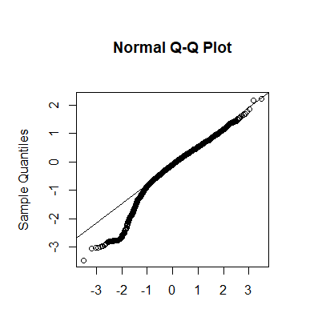 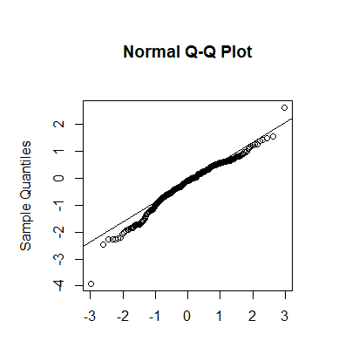

Afternoon (Denning and Non-Denning) Afternoon (Denning)

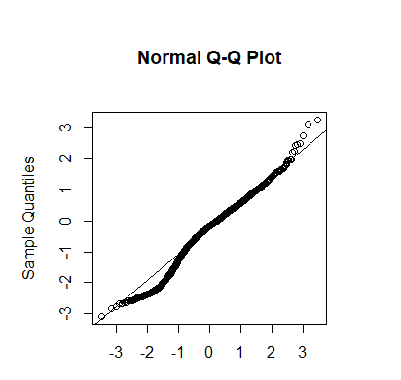 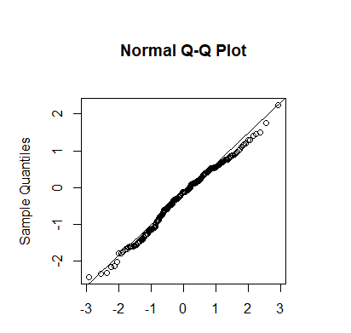

Night (Denning and Non-Denning) Night (Denning)

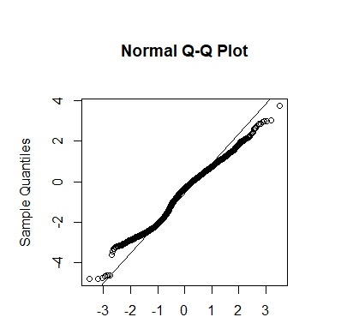 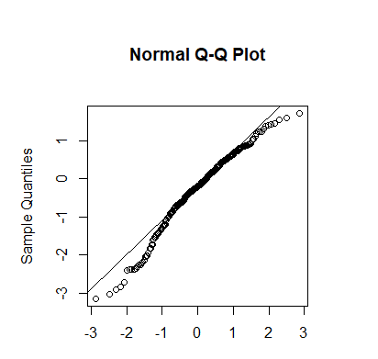

24h (Denning and Non-Denning) 24h (Denning)

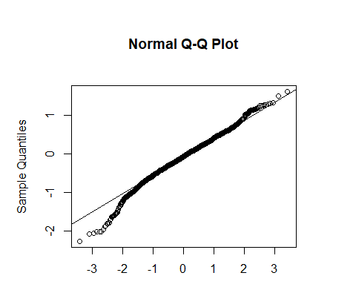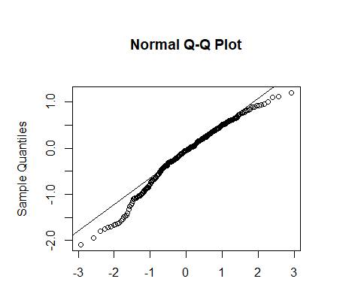

**Appendix Figure 2.** Testing for Homoscedasticity of residuals

Morning (Denning and Non-Denning) Morning (Denning)

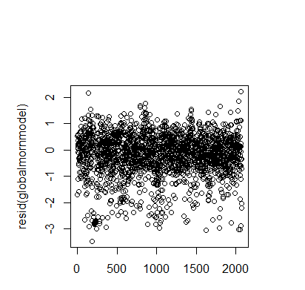 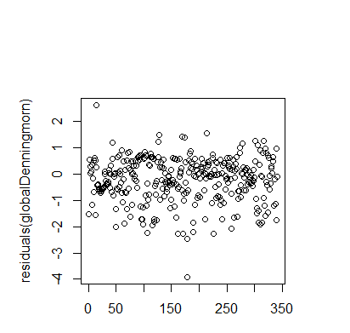

Afternoon (Denning and Non-Denning) Afternoon (Denning)

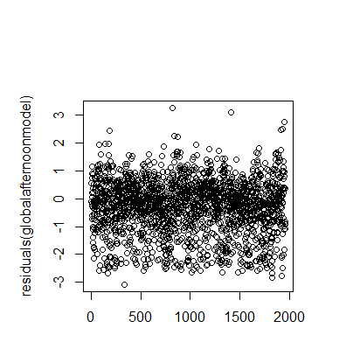 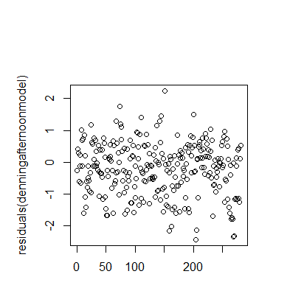

Night (Denning and Non-Denning) Night (Denning)

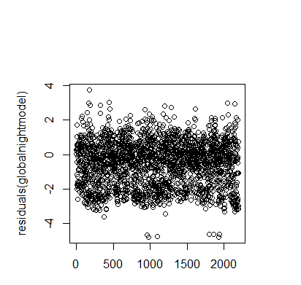 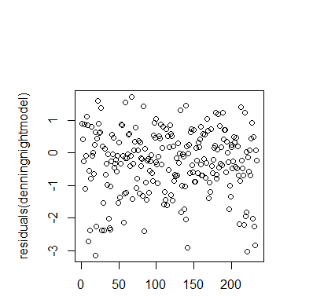

24h (Denning and Non-Denning) 24h (Denning)

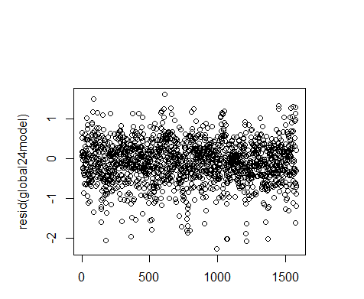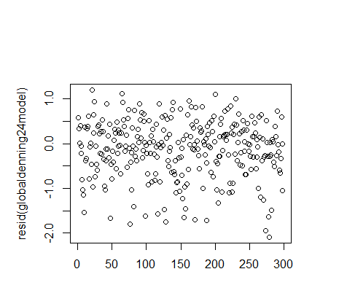

**Appendix Figure 3.** Histograms of model residuals

Morning (Denning and Non-Denning) Morning (Denning)

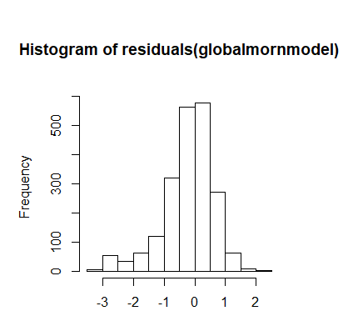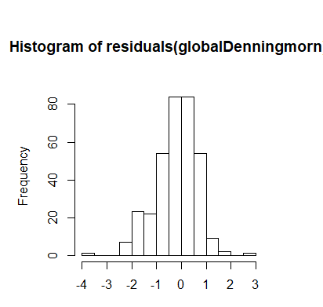

Afternoon (Denning and Non-Denning) Afternoon (Denning)

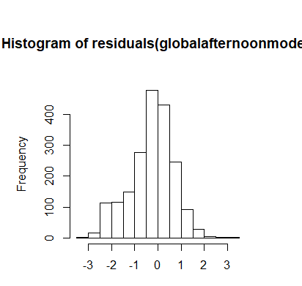 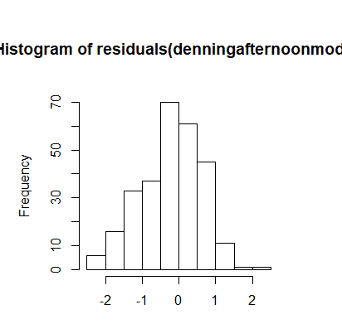

Night (Denning and Non-Denning) Night (Denning)

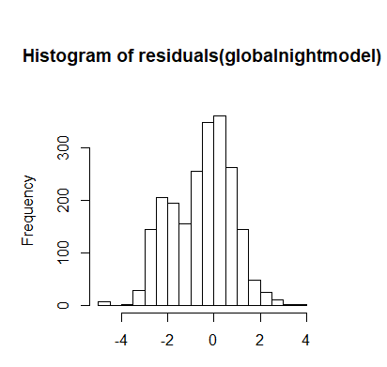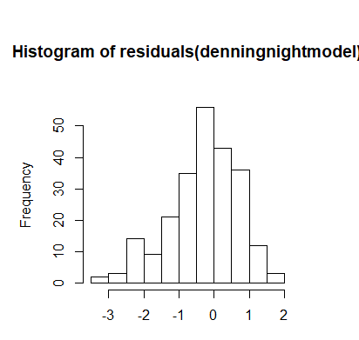

24h (Denning and Non-Denning) 24h (Denning)

